**TITLE OF THE INTERNATIONAL SCIENTIFIC WRITING COMPETITION ARTICLE**(times new roman 16, center, bold)

**1 Author’s name*, Author’s name,3 Author’s name *(times new roman 12)***

1Faculty, University Name

2Faculty, University Name

3Faculty, University Name

*Corresponding Author:

emailexample@gmail.com

**Abstract**

*The abstract section of a research paper should contain five key elements: the background, the aim or research objectives, the method or framework used, important results or conclusions, and suggestions. The abstract should be* ***no longer than 250 words*** *and should not include unusual or difficult-to-understand abbreviations. Additionally, an abstract should be written in both Indonesian and English if the full text is in Indonesian. If the full article is in English, then only one abstract in English is needed. The abstract should be written in one paragraph. Times New Roman, Italic, Font size 10, spacing 1.*

***Keywords****: Maximal five words, keyword, keyword, keyword, keyword*

# 1. INTRODUCTION

The introduction of a scientific article should include the research background, research problems and objectives, as well as a literature review.

It is recommended that scientific articles should have four main parts: introduction, methods, results and discussion, and conclusion. The article must consist of **7 to 12 pages**. Additionally, it includes thanks and a bibliography. The text should be written in Times New Roman font size 12 and each paragraph should start with an indent. The article must use 1.5 spacing and between paragraphs should be 6 pt. The text should be written in proper English, with non-English words (including regional languages) written in italics. The file format accepted is Microsoft Word with the extensions *.doc and *.docx. Please send the files to the Google Form of ASCiting committee.

# Technical Quotes

In-text quotations are written at the end or beginning of the sentence by writing the author's name and year of publication. Please follow APA Style (7th Edition) as citation and referencing guide. If there are up to two authors or authors, they are written with the author's last name (Abdu & Bayu, 2010). If there are more than two, the quotation is written with the first name of the author/author and et al. as well as the year of publication (Badu et al., 2001). Procedures for writing a bibliography must follow the standard format as can be seen in the Bibliography section at the bottom of this guide. In-text citations must be consistent with the Bibliography.

# 2. METHOD

This chapter contains research methods consisting of research types, data collection techniques, and data analysis. (Ardi, 2018)

# 3. RESULTS AND DISCUSSION

This chapter contains research results and discussion.

# Figures and Tables

Images or graphs that are included in a paper should be inserted into the text with the title of the image or graph written at the bottom in the center position. The image should have sufficient resolution with grayscale or black and white. It is recommended that images be placed as close as possible to the explanation of the image or graphic. This is important because the images or graphs in the paper will be printed in gray scale or black and white.

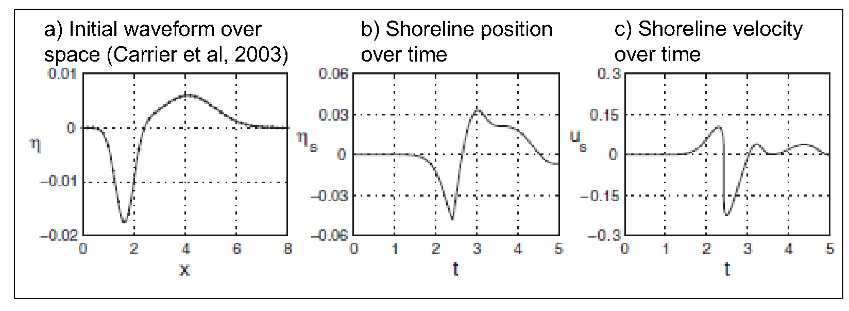

**Figure 1.** Examples of images in papers (Synolakis, 1987).

The table title is written close to the left in 11pt font. If the data is secondary data, the data source must be stated (written in 10pt font).

Table 1. Example of a table for a paper

|  |  |  |  |
| --- | --- | --- | --- |
| **Event Date** | **Location** | **Trigger Tsunami** | **Impact** |
| 2010/10/11 | Xxxx | Undersea earthquake | 100.000 casualties  100 ha |
| 2004/12/26 | Aceh | Undersea earthquake | 230.000 casualties  21 countries |

**Source**: Vsidlock (2010).

# 4. CONCLUSION

Conclusions are presented in relation to the paper presented above. It is recommended that it be written in bullet point form and free from speculation. (numbering)

# ACKNOWLEDGMENTS

Acknowledgments can be written by mentioning the parties who have contributed to the research, writing process, and also supported travel for the presentation of this paper. *Optional

**NOVELTY**

Discovering new problem-solving concepts can help address issues. *Optional

# References

Following APA 7th Edition.

Kumar, S., Groth, A., and Vlacic, L., (2013). An Analytical Index for Evaluating Manufacturing Cost and Performance of Low-Pressure Hollowfibre Membrane Systems. *Journal Elsevier*, Vol. 332 pp. 44–51.

Paristiawati, P., F., (2013). Pengembangan Perangkat Lunak Aplikasi Analytic Hierarchy Process (AHP) pada Manajemen Perawatan untuk Menentukan Strategi Perawatan yang Tepat pada Mesin – Mesin Produksi (Studi Kasus PT. Coca – Cola Amatil Semarang). *Skripsi.* Universitas Gadjah Mada, Yogyakarta.

Monroe, K., B., (2007). *Pricing Making Profitable Decision,* 3rd Ed*.* Singapore: McGraw-Hill.

Bagadia, K., (2008). Make Your Maintenance Department a Profit Center,akses online 30 Juli 2012. *URL: http://www.snoeksrealstate.com/files/Maintenance%20profit%20center.pdf*.